Here’s a report from our latest Iron Smelt down at Tunnel Mill, south of Rochester, MN the weekend of Oct. 2, 3 and 4, 2015. This reporter was one of the team members.
As in the past, I got hooked into managing the event, but I had plenty of willing help.

Pete Stanaitis
------------------

From: Randy Purchase [mailto:rarepurchase@comcast.net]
Sent: Sunday, October 04, 2015 12:06 PM
To: Bob Brown; Bryan Schaupp; David Newton; David Wiblishauser; EUGENE C VOGL; Jerry Sullivan; Jim Moenck; JOHN ADAMS; Justine Stephens; KnifeDogs.com Forums; Lennard Zimmel; martin pansch; Marty Hicks; Peter Creese; Phil Bryans; Rick Korinek; Pete & Sheri; agbarr@aol.com; Beth; Jill Ahart; Jim Gemcutting; Joe Newton; Keith Johnson; Pastor Dave Greenlund; Rich Pogue
Subject: Steel the old way

O.K. this is how our ancestors made their first iron ore. This is just a rough idea of how we did this. Pete Stanaitis will have much more detailed article on his youtube:frenchcreekvalley site (in a couple of weeks). There is a lot more to Tunnel Mill then what I'm showing here. It was a great experience. Yes! we used iron from MN. Red rocks and made iron metal from then. If we ever go back to the spear we will need to know how to do this again. You just can't beat fun for having a good time.
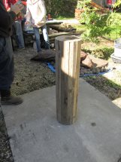
The form

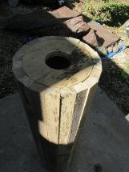

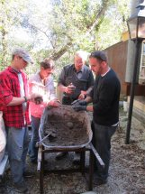
3 Kinds of Clay, peat moss, and sand is what we made the outside of.

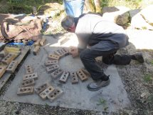

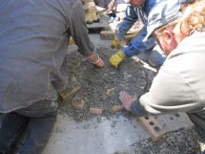
First layer of bricks

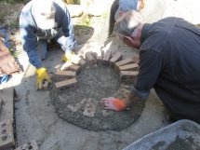
Second layer

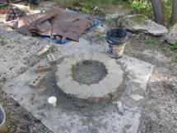

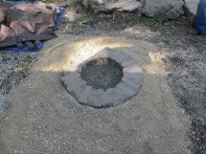

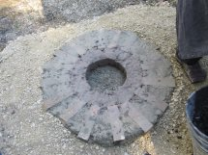
3rd layer of mortar in side.

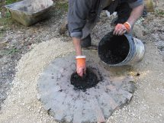
Fill with charcoal

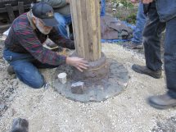
Do a layer then tie it with string.

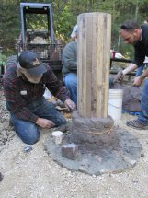

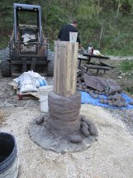

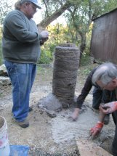
This took all day to make.

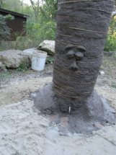
Fred Cork

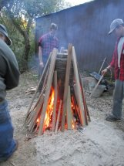
Harden the outside

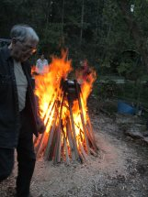

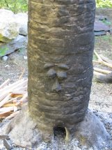
OH no!

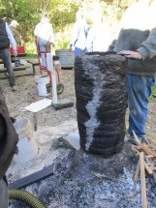
We got a crack

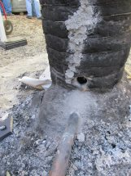
We fixed it.

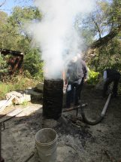
Start it with a wood fire, then fill with charcoal

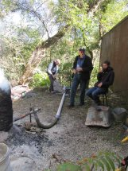
Add air


Pete’s air flow gages

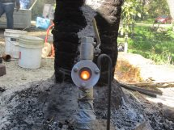
We got heat

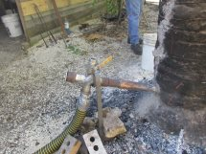

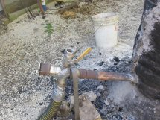

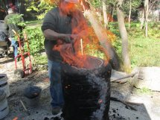
A layer of charcoal and a can of iron ore. we put in over fifty layers of ore, and charcoal.

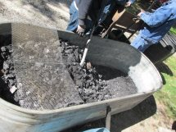
This thing was full of charcoal. That is a cattle trough.

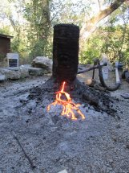

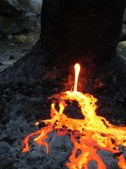
Tapping off the slag

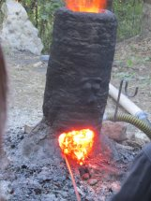
Taking out the bloom

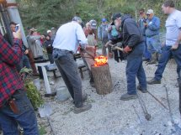
This is it.

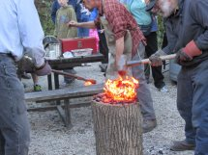
Hammering (consolidating) Our chunk of iron

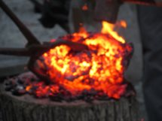

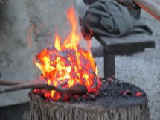

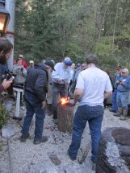
Let's make an axe! No let's make a spear. Kids with gray hair. There is just no end to it. Partytime!

